Barnoldswick Baptist Church
The Early Years

Barnoldswick claims the place of having the earliest continuing Baptist church within the Yorkshire Baptist Association. Two cousins, William Mitchell and David Crosley were significant in the work of planting and reviving Baptist life travelling backwards and forwards across the Pennine hills.
Their work linked twenty small Baptist groups called the “Rossendale Round”. By 1694, Barnoldswick was not only a preaching station but had a meeting place bought on the signature of Crosley.
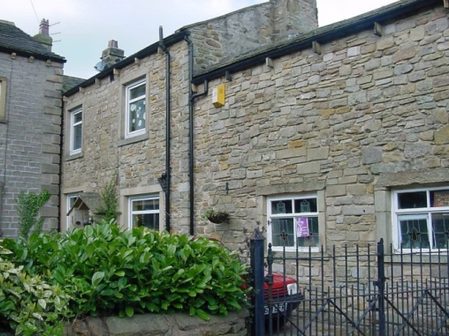

This cottage and barn on Walmsgate was the first meeting place of Barnoldswick Baptists
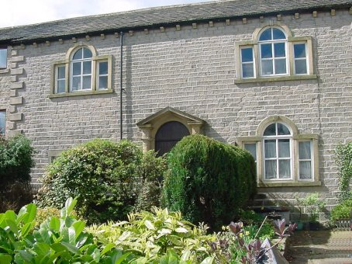

Early Ministry
The work in Barnoldswick and throughout the surrounding area expanded, especially under the pastorates of the Alvery Jackson (1718-1763) and Nathan Smith (1790-1831). In 1717 Jackson preached a long and detailed sermon to encourage the church to sing in worship, as up to that point it had not been allowed!

Naturally there was close involvement with the Lancashire and Yorkshire Association (as it was then) and cottage meetings were held in nearby communities, from where many worshipers came.

Earby became a separate church in 1819 and Salterforth in 1861.

The Barnoldswick church divided into two in 1868: Bethesda Baptist Church and North Street Baptist Church.

In 1959 the two Barnoldswick churches shared a pastor and in 1971 were reunited to form Barnoldswick Baptist Church. Architects were appointed in 1973/74 to look at a new building, and so the Baptist Church Centre was constructed.

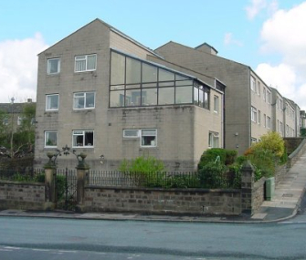
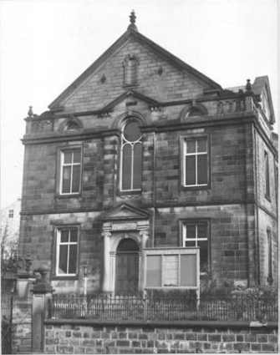
Bethesda Baptist Church

David Crosley House
now stands on the site of Bethesda Baptist Church

North Street Baptist Church
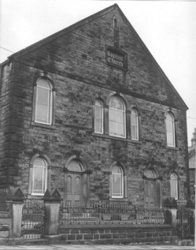
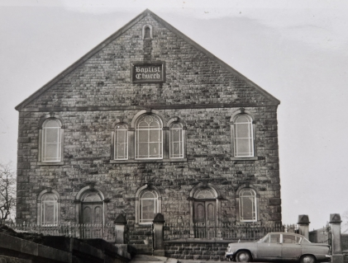

The building on Manchester Road which was opened on 4th June 1977

