

West Craven Baptist Church

Newsletter

25th April 2025

**Welcome to our May newsletter**

**Sundays in May**

4th May - Sunday Stroll at 10.00 a.m. from Mount Zion. CAFE worship at 10.30 a.m. at Barnoldswick led by Richard.

11th May - 10.30 a.m. United service with a Christian Aid focus at St.Mary’s, Kelbrook.

18th May - 10.30 a.m. Morning worship at Barnoldswick led by Mick.

25th May - 10.30 a.m. Communion service followed by a church meeting at Barnoldswick led by Julie and Mick.

**Weekly Events**

**Everyone is very welcome. Please bring your friends along.**

**Playgroups** – Tuesdays at Barnoldswick at 10.00 a.m. and Wednesdays at Mount Zion at 10.30 a.m.

**Warm Welcome** – Mondays at 2.00 p.m. at Barnoldswick

**Renew Wellbeing Cafe –** Wednesdays from 1.00 p.m. at Mount Zion.

**Small Groups** - Tuesdays at 10.30 a.m. and 1.00 p.m. at Humble Pie Cafe, Earby, led by Mick Dewhirst.

**Julie’s news**

Julie will be at the Baptist Assembly in West Bromwich on 16th – 18th May

Northumbrian Collective: Some of you are aware that I am part of the Northumbrian Collective, which is a group of friends with the shared values of Listening Well, Thinking Deeply and Living Authentically. If you are interested in finding out more, we have blogs and podcasts which are available on our website: www.northumbrian.org

**What’s On in May**

**Earby Medieval Mayhem –** 11th May from 11.00 a.m. Please see information below.

**Christian Aid Week** – 11th - 17th May. Helen will have a selection of hand made greetings cards available for donations for Christian Aid after the service on 18th May. If anyone else would like to offer craft items or baking to go on a stall please let Helen know.

**Pastoral Team meeting –** Monday 12th May at 10.00 a.m. Please pray for our pastoral team.

**Trustees meeting –** Monday 12th May at 7.30 p.m. at Barnoldswick. Please pray for our trustees.

**Safeguarding Training session** – taking place on 17th May from 9.30 a.m. till 12.30 p.m. at Barnoldswick, led by the YBA and hosted by Julie & Gary Lewis.

**The BU Assembly** – taking place from 16th to 18th May in West Bromwich.

**Lego Church**

Our next Lego Church is on Sunday 18th May at 3.00 p.m. in the Alvery Jackson Hall, Barnoldswick. Suitable for all ages. Please pray for Lego Church.

**Church Picnic** – Sunday 25th May at Sough Park. Please see information below.

***

**Church Secretary**

As we didn’t appoint a Church Secretary at the AGM, we have opened nominations for a member of the secretarial team, who will be a trustee/deacon by nature of the role. The appointment is for the time period up until our next AGM, so just less than a year. The closing date for nominations is Sunday 4th May and nomination slips are available in the Narthex at Barnoldswick.

A Church meeting will be held on Sunday 25th May

- To elect a member of secretarial team (who will also be a deacon/trustee)

- To affirm those who wish to become church members

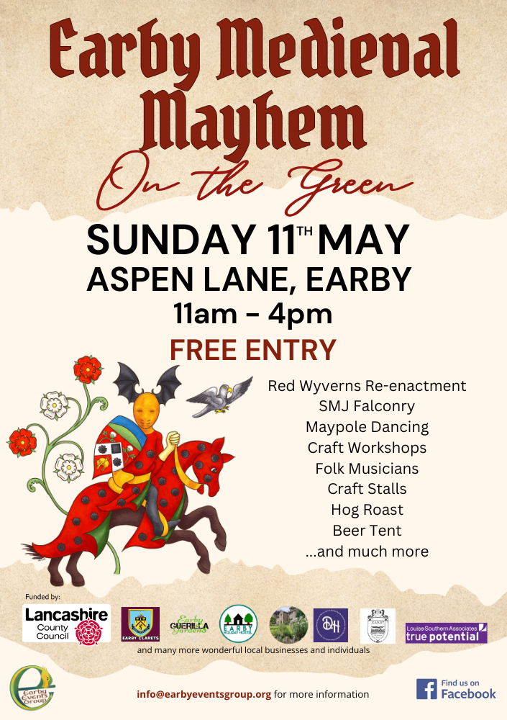

**Medieval Mayhem**

This community event will take place in Earby on 11th May from 11.00 a.m. - 4.00 p.m.

Mount Zion will be hosting tea, coffee and cakes during the event.

Any donations of cakes or buns would be much appreciated. Also if you have an hour or two to spare, teams in the kitchen and serving in the hall on a 2 hourly shift are required. If you can help please speak to Alison.

Thank you.

**Church Picnic - Sunday 25th May**

Earby Memorial Bowling Club are holding a Big Bowls Weekend at the end of May. We have been invited along, so we are going to have a Church Picnic at Sough Park after the service and Church meeting on Sunday 25th May. Those who wish to have a go at playing bowls can do so. Please bring a picnic lunch. Hot drinks will be available at the park.

**Prayers for the world from Tearfund**

**Instability and Insecurity in Syria**

Please pray for lasting peace in Syria. Though the war has de-escalated in many areas, instability and insecurity remain in many areas of Syria. Pray for wise leadership and reconciliation across divided communities. Please pray for the faithful Christian community in Syria and for encouragement, boldness and protection for pastors and believers as they continue to be salt and light in difficult circumstances. Please pray for Tearfund’s partners in Syria who are providing support to families and children as millions of Syrians are still affected by displacement, poverty and limited access to basic needs. Pray for wisdom, strength and the resources they need to continue serving effectively.

Please pray for healing from trauma, especially for children and young people who have grown knowing only conflict. Pray for programmes and people to bring emotional and spiritual restoration.

**Heatwaves in India**

India has been experiencing heatwaves in the North, with temperatures reaching 40C in New Delhi. This has triggered severe thunderstorms and caused loss of life, as well as extensive damage to crops. Pray for the weather to ease and the temperatures to drop in India.

Ask God for access to resources and support for those who have had their livelihoods destroyed.

**HIV in Sub- Saharan Africa**

An estimated 25 million people are living with HIV in Sub-Saharan Africa, which is more than two-thirds of the global total of 38 million living with this disease. In Nigeria nearly 2 million people are living with HIV, with many relying on receiving aid-funded medicines. Pray for the support to global health provisions of medicines and treatment which not only saves lives around the world, but prevents outbreaks spreading internationally.

The next newsletter will be issued on **Friday 30th May.** Please send any information for inclusion by **Wednesday 28th May.**

**Want to get in touch?**

Julie (minister) [thatjuliebryan@gmail.com](mailto:thatjuliebryan@gmail.com) 07572 274050

NB: Julie’s normal days off are Tuesday (study day) and Friday.

Alison (safeguarding): [alisonm1961@yahoo.co.uk](mailto:alisonm1961@yahoo.co.uk)  07498 878480

Helen (news sheet) [ase28@hotmail.com](mailto:ase28@hotmail.com) 07709 721809

(Charity number: 1190946)

**Please let Helen know if you no longer want to receive these news sheets**