The Beginnings of a Baptist Church in Earby
Before 1819, many Earby Baptists had attended the Baptist Church in Barnoldswick; others went to Cowling Hill. They had to walk to these chapels in all weathers, so as their numbers increased it was felt that that the time had come to form a church in their own town. They thought it would be more convenient, and that they could be of more use and influence in the village as a separate church than as part of the Church at Barnoldswick.
So on Good Friday 1819, twelve men and thirteen women gathered in a cottage in the village to celebrate communion as a separate Church.

The first pastor was 32 years old William Wilkinson. He worked as a teacher and handloom weaver to supplement the annual stipend of £10.
To raise the funds needed to build a chapel, William Wilkinson set off on a begging pilgrimage to London, seeking support from the Baptist Churches in the towns he passed through on the way.
As he walked the 500 mile journey, Wilkinson lectured, preached, and visited wealthy laymen, and wherever he went “his eloquence and zeal touched hearts and opened purses.”

When he reached London, he asked the minister of a large Baptist church in the city if they would collect for his cause, they agreed, on the condition that William Wilkinson conducted the service, preached, and then made his own appeal to the worshippers.
It is reported that Wilkinson was “appalled at the thought” as he expected his northern accent and unpolished manner would lead to ridicule. He asked the minister if there was another way but was without success. He mounted the pulpit steps to face the largest congregation he had ever seen. The result of this was a very generous collection and he returned to Earby with a grand total of one hundred pounds.

With the help of this money a chapel was built in Gravel Pit Road, ('Grelpit' as it was called), now Red Lion Street.
Members of the Church dug the foundation and the chapel was opened on Good Friday in the year 1821, just two years after the church began.

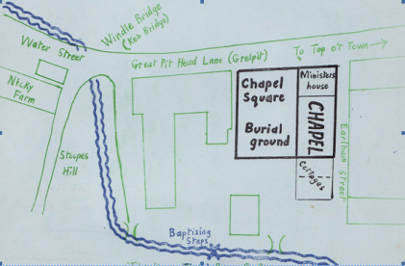

Map showing Chapel location 1821

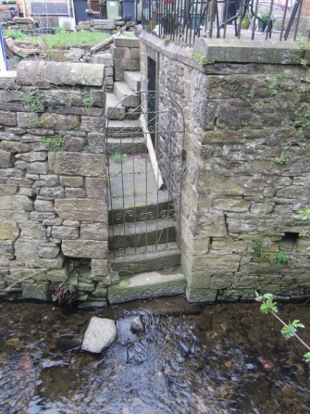

Believers would have been baptised

in Earby beck.

The steps are still visible today.

In less than 40 years this first building had become too small and in 1859, it was decided to look for a site on which to build a larger chapel.

A site was found, but the deacons were afraid that the site would not be for sale or that it would be too costly. When the owner, Mr Thomas Riley, was asked for his terms he asked for only 10 shillings!

A month later when the formal transfer was taking place, the money was laid on the table, and the document was signed. When one of the deacons reminded Mr Riley to take the money, he pushed it back across the table and said “This is my contribution to the building fund.”

Mount Zion chapel was opened on Good Friday 1861.
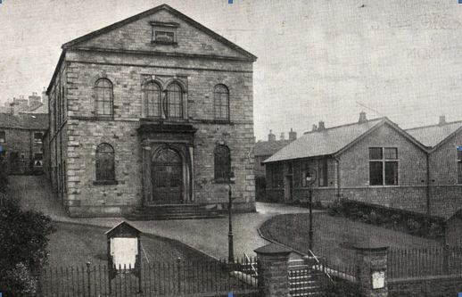

Mount Zion Chapel, Water Street

The chapel was demolished in the 1980s. Wilkinson Mount and Preston Beck flats were built on the site.

The church building in use today is the old Sunday School building which was built in 1922.

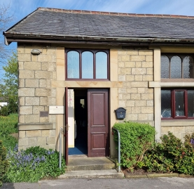
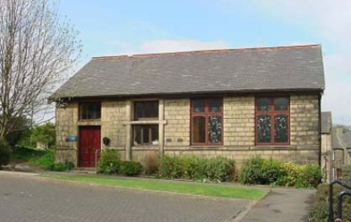

In 2019, Mount Zion Baptist Church celebrated its 200th anniversary.

