The Baptist Church in Salterforth
The Church was founded in the early 1850's by the members of Barnoldswick Baptist Church. Some evidence points to 1852.
By the end of the 19th century plans were afoot to build a new church and this was completed in 1903.

Today, the original church building is also used as the Village Hall.

Very few early records of the life of the church exists, so most of it's history is by hearsay and a few photographic records.

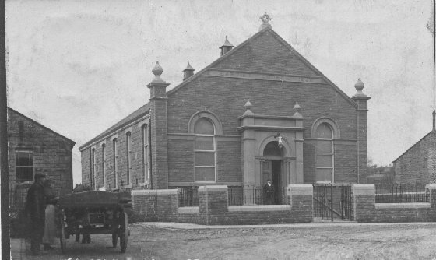
The 'new' church built in 1903
with the original chapel
on the left

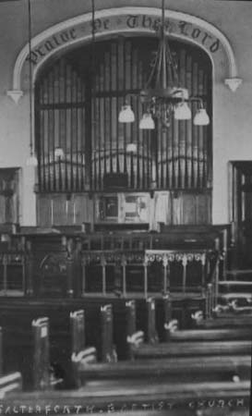
The interior of
the 'new' church
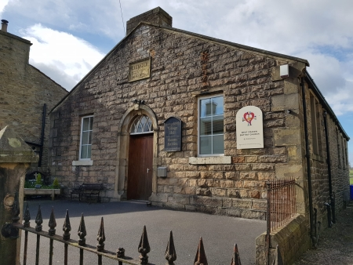
The original chapel which now serves as the Village Hall and Baptist Church.

